Report: Content Curation Task
In this report I’ll be discussing why I am using LinkedIn for the assignment and why I use it in my personal life. My personal experiences and facts and figures found online will be used as my discussion criteria.
Content
What is content curation 1
Why LinkedIn 1
Conclusion 1
Reflection 1

What is content curation?
Content curation is the process of gathering, creating, and compiling information on a specific subject and presenting it to readers.
In fact, content curation is found almost everywhere on the Internet, on social media pages, RSS feeds, and even social bookmarking sites like Digg. It’s also an extremely useful tool for marketers, who can use curated content to increase the value whether for B2C or B2B marketing.
Importantly, content curation isn’t just about using other people’s content, as curation is often used to source topics, industry news, and ideas for creating unique content. Content curation applies to many parts of the Internet including social media platforms like Twitter, blogs, company websites, newsletters, and even picture sharing sites like Instagram.
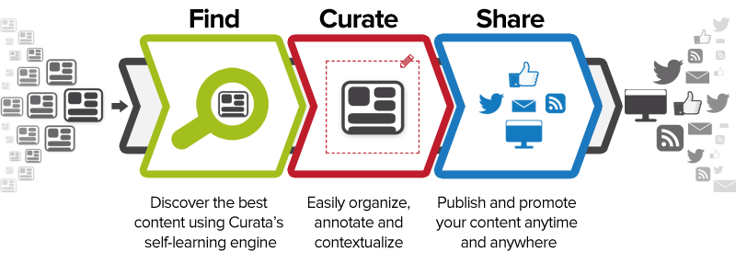

LinkedIn

What is LinkedIn?
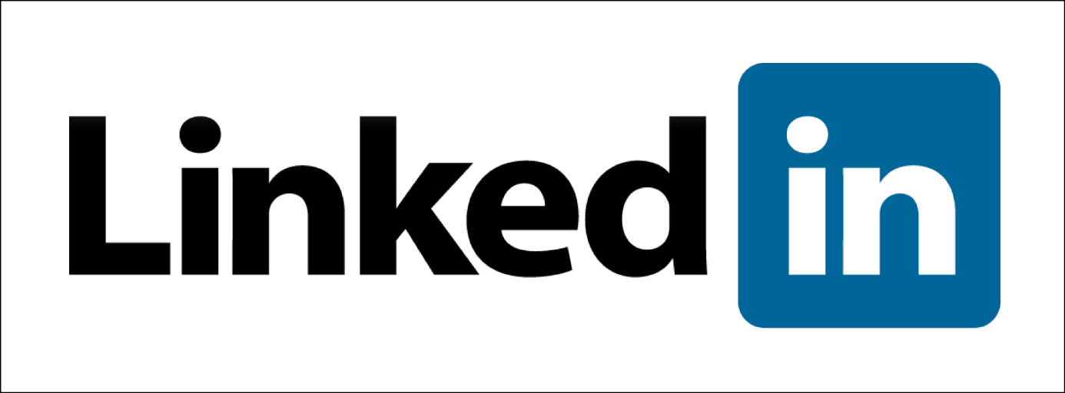
LinkedIn is a social networking site designed specifically for the business community. The goal of the site is to allow registered members to establish a network of people they know professionally and to keep track of the businesses and companies they are interested in.

Why LinkedIn?
For me content curation is overlooked. I am not using it and I am not planning to use it in the nearby future. It's hard to create enough engaging content to make an interesting source of information.
The part that is interesting for me is that I can stay in touch with the parties I'm interested in. Being provided with information and value with minimal effort is what I want. And all of that I can find on LinkedIn.
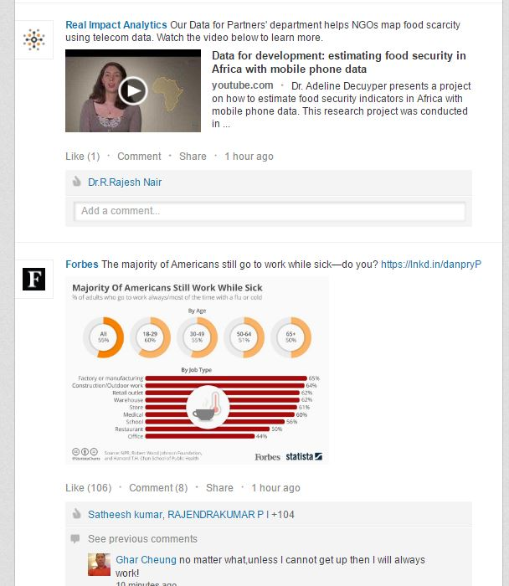
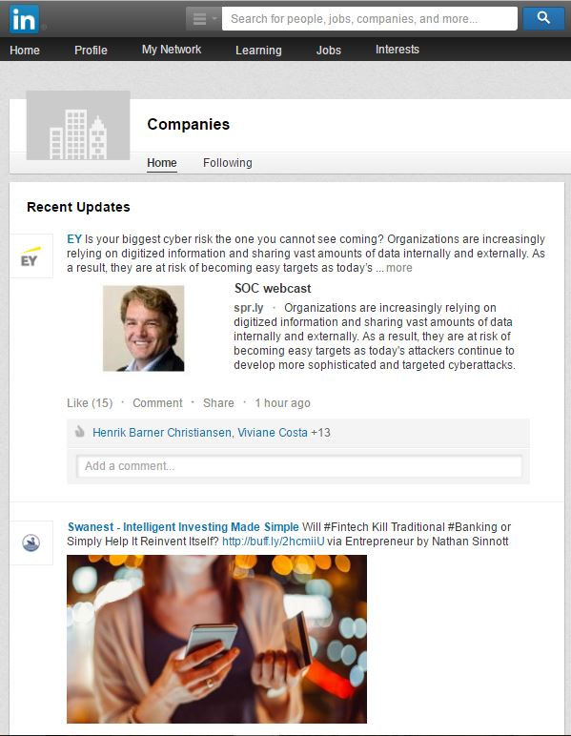
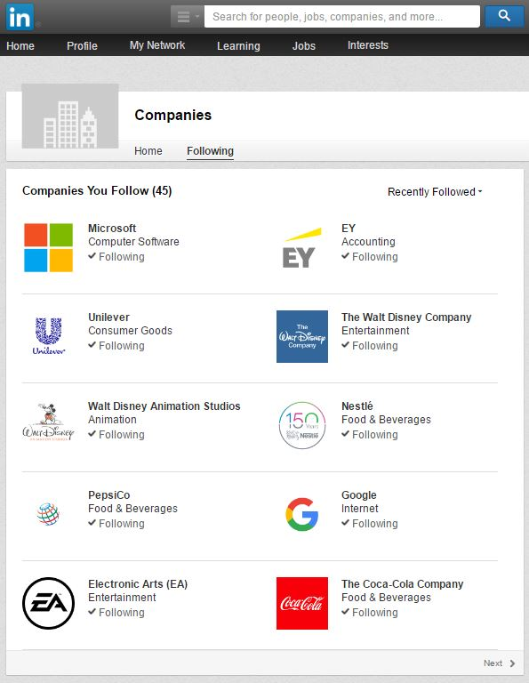
Not only am I building a professional identity online and am I expending my network but I get the latest new, inspiration and insights of the companies I'm interested in. And that's also what content curation is about as a user.

Conclusion
Why should I use a program only once for an assignment when I’m already using LinkedIn for over a year. LinkedIn offers everything I want and I find it the perfect social media platform to keep my preference content structured and up to date.

Reflection
Content curation is a perfect topic to mention in the classes of E-skills. There are popping up more and more websites and sources of information on the web so it’s important for a person to find the info they want and structure it like they want to.
As for the assignment, I slightly took another road. It isn’t interesting for me to try out a content curation tool that I am never going to use while I am using LinkedIn to keep track of business information.

Sources
Hanski, M. (2016, February 12). e commerce. Retrieved December 10, 2016, from https://blog.getresponse.com/what-is-content-curation-and-why-do-you-need-it.html
Rouse, M. (2016). LinkedIn. Retrieved December 12, 2016, from http://whatis.techtarget.com/definition/LinkedIn

