Web Task

Symbaloo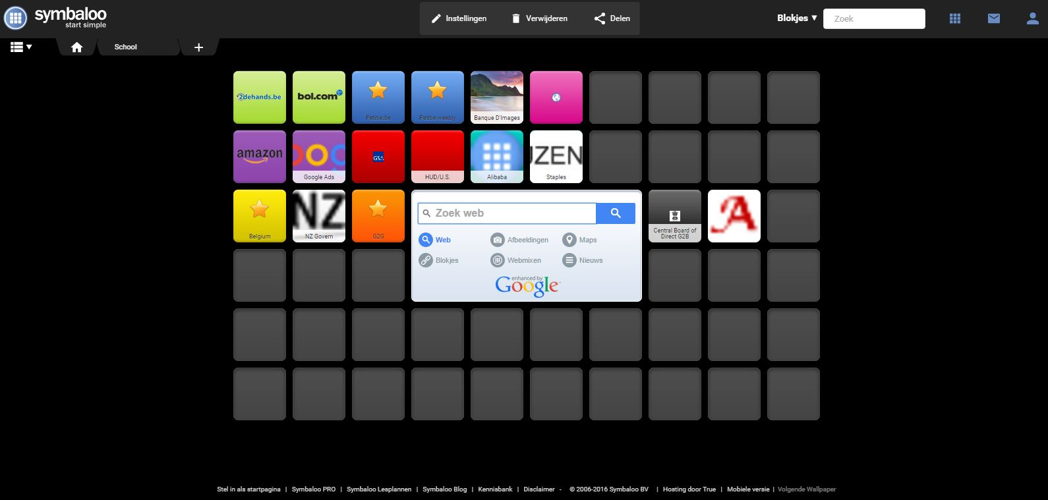
Symbaloo is a browser start page where you can easily navigate the web an choose your favourite sites into one interface. Save you bookmarks in the cloud and use them from any device, anywhere you want.
Categories
Together with Joran van Ghyseghem and Jane Mulopo, I made a Symbaloo grid to present different websites based on the following categories.
C2C websites: http://www.2dehands.be
http://www.bol.com
B2C websites: http://www.amazon.com
http://google.com/ads
G2C websites: http://www.belgium.be/nl/online_dienst
https://www.govt.nz/
C2G websites: http://petitie.be/
http://petitietegenverhoging.weebly.com/
G2G websites: https://www.ssa.gov/gso/gsowelcome.htm
B2G websites: http://www.gsa.gov
http://portal.hud.gov/
C2B websites: http://www.istockphoto.com/be
https://www.elance.com/
B2B websites: http://www.alibaba.com/
http://www.staples.nl/
G2B websites: http://www.incometaxindia.gov.in/Pages/default.aspx http://webarchive.nationalarchives.gov.uk/20070603164510/http://businesslink.gov.uk/bdotg/action/home? domain=www.businesslink.gov.uk&target=http://www.businesslink.gov.uk/
​
​
This was a simple way for us to present the websites and to easily navigate from site to site during our presentation.

Conclusion and reflection
Together with Joran and Jane, I made a Symbaloo-grid to present our chosen websites. Symbaloo is a very useful website to use as your homepage. The fact that you can log in to the site on every device to keep your bookmarks is fantastic. As for the assignment it was nice to work with Jane and Joran. We quickly decided what we wanted to do, divided the work and we worked together to perform our presentation. I don’t think I will use Symbaloo as my personal homepage since I am so used to Google, which is for me still the best option. But if, for some reason, I have to save a lot of websites, instead of saving them as bookmarks I will maybe use Symbaloo for it.

