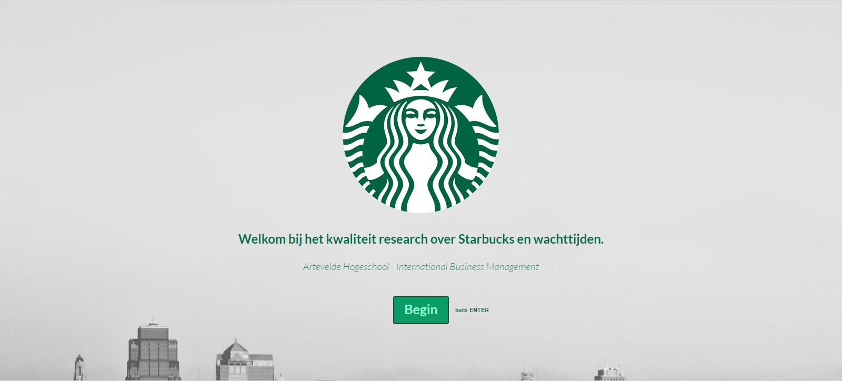
Content
What 1
Statistics 1
Conclusion 1
Reflection 1
Brussels 1

What
For the course of International Marketing&Research Jelle Van de Perre, Ruslan Podgaetskiy, Anthony Phan and I made a survey. As you can see, our survey was about Starbucks. We did field research in multiple cities. The survey I use for this assignment is the one we used for Brussels. The survey itself is in Dutch. The survey was made with Typeform. As you can see we've implemented the Starbucks colour pallet so that our survey would look more professional and in the Starbucks house style. You can check our survey at:

Statistics

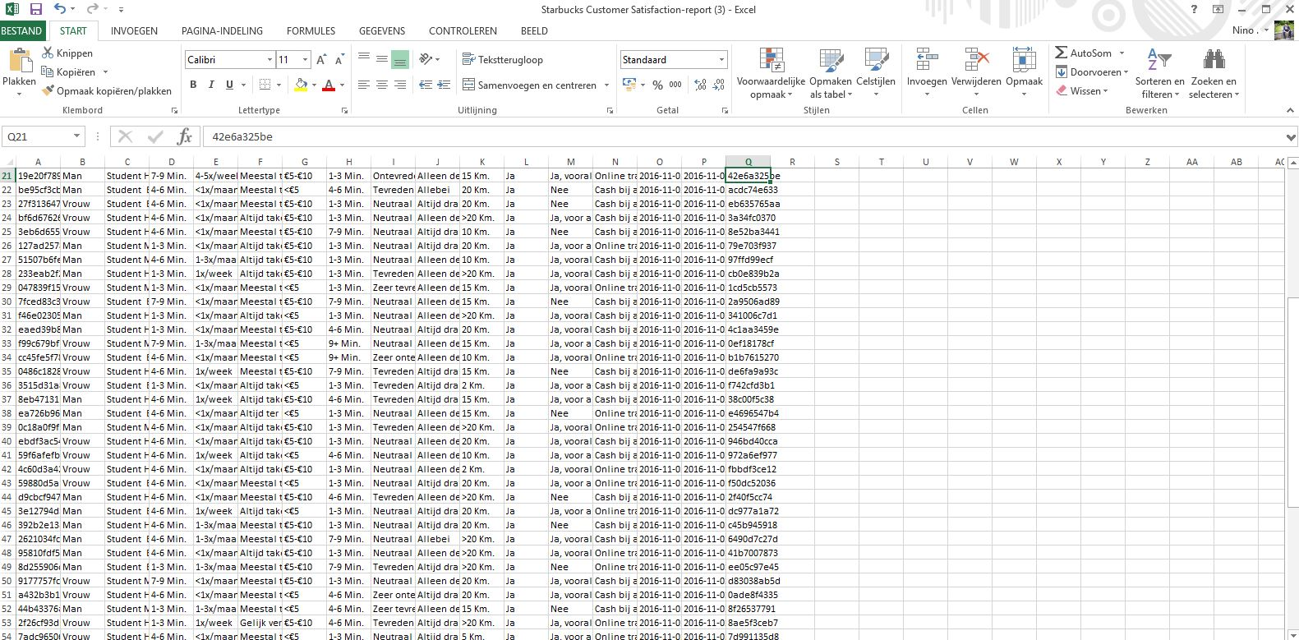 Brussels

We have visited two Starbucks shops in Brussels. The one at de Grote Markt and the shop in Bruxelles Central. The survey was taken in Dutch and we translated it to French for the French speaking visitors. This questionnaire was taken on the 2th of November between 12:00 and 16:00We came to the conclusion that this was rather a calm day for both of the Starbucks shops. We think that this was due to the autumn holidays. We have collected 70 answers.

Gender:
We interviewed 38 male respondents and 32 female respondents. There is no link or reason for this difference.

Occupation:
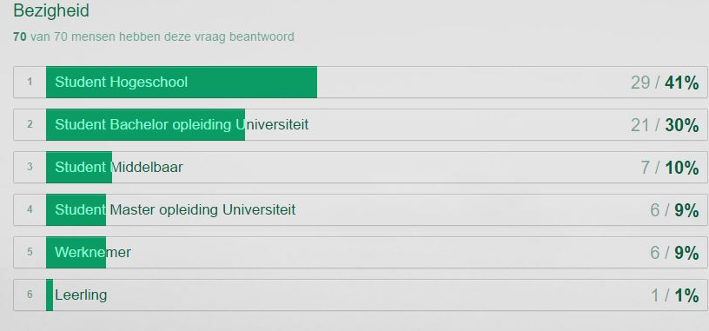
We had expected more employees to visit Starbucks this day since the survey took place in the autumn holidays. 41% of the people interviewed were college students. All of them were spending their free time in the city for shopping and relaxation.
39% were university students. They passes by before or after their classes.
10% were secondary school students, 9% were employees and the other 1% were primary school kids.

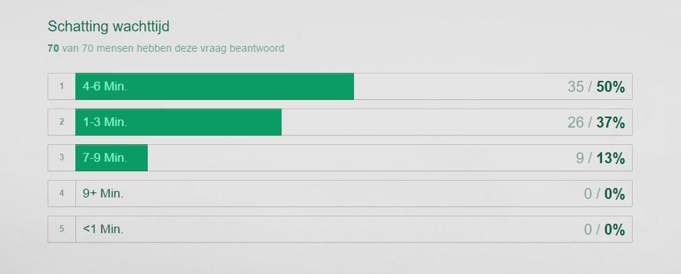
Estimated waiting time:
The time the visitors thought they had to wait before getting their order.
Most people thought they would wait for about 5 minutes. So 50% of the interviewees thought they would have to wait between 4 and 6 minutes. When the ques were not that long people thought it would take less than 3 minutes. 37% took this option.
It surprised us that 13%, which we think is a lot, thought that they would have to wait longer than 7 minutes. But no one thought it would take longer than 9 minutes.

Frequent Starbucks visits:
Most people, 60%, visit Starbucks once a month.
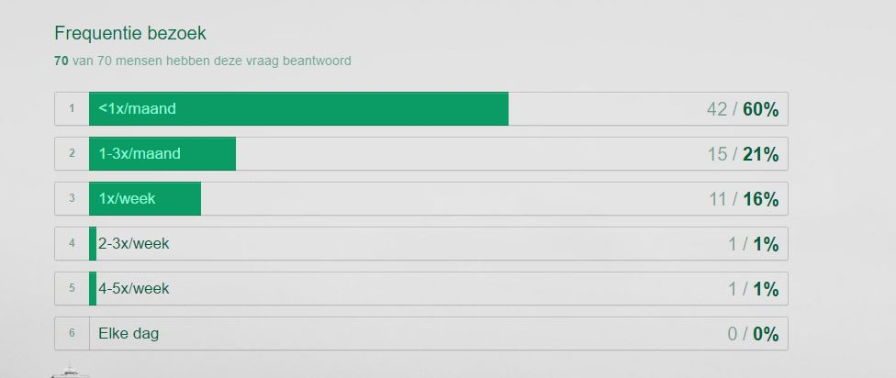
We consider people who visit Starbucks more than one time a month frequent visitors. So we have 40% frequent visitors. 21% of that are people who come one to 3 times a month. 16% visits once a week and we have 2% percent who we consider to be the die-hard customers who visit Starbucks more than 2 times a week.

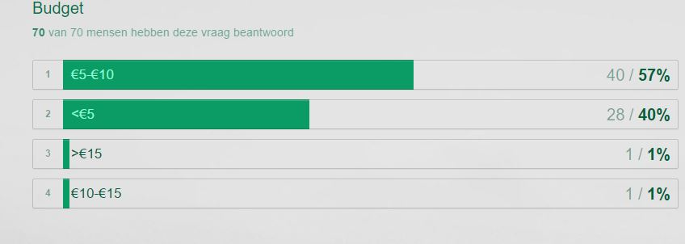
Budget:
People mostly spend between 5 and 10 euro per order. In Brussels this was 57% of the customers we have interviewed. 40% of the people spend less than 5 euro. Only 2% spends more than 10 euro.

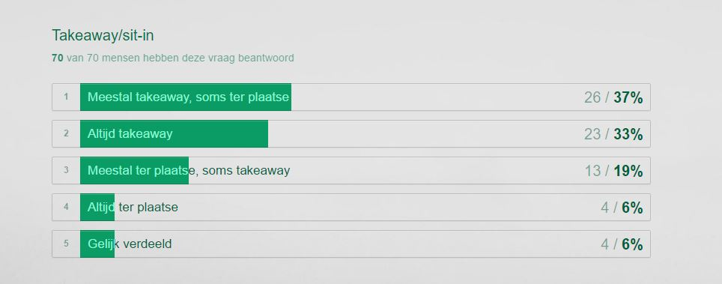
Takeaway vs sit-in:
As we had expected, the majority of the people chooses for takeaway. 37% likes to take away their order and sometimes stay in the shop. 33% always does takeaway.
19% of the interviewees mostly stay in the Starbucks and take their order away sometimes. 6% always drinks or eats his product in the Starbucks.
The other 6% of the results were matched evenly.

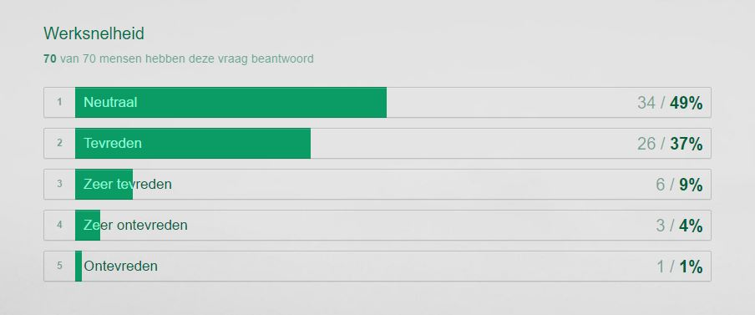
Satisfaction with waiting time:
The time period from entering Starbucks until getting your order.
Overall, 46% of the visitors were happy with the waiting time. 49% didn’t have a clear opinion and stayed neutral and only 5% were not satisfied.

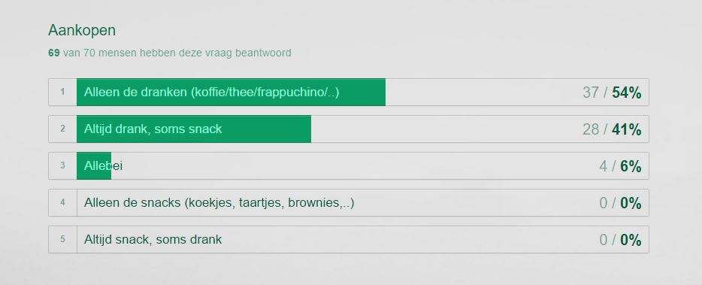
Order
As we had expected, more than the half of the visitors were only thinking of buying drinks. No one would only buy a snack.
54% buys only a drink. 41% always buys a drink and sometimes a snack. The other 6% buys both a drink and a snack.

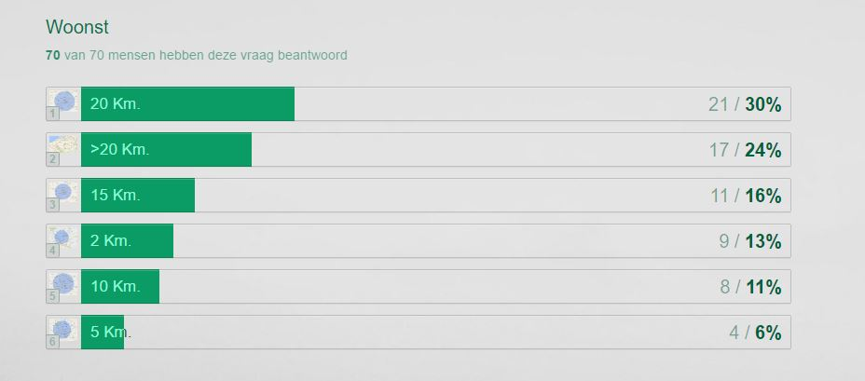
Living:
We wanted to know how far people lived from the Starbucks in Brussels.
24% lives farther than 20km. The other 76% lives within a radius of 20km.

Smartphone:
Only 4% of the interviewees doesn’t have a smartphone. The extreme majority do have a smartphone and use it on a daily base.

Interested in application – personalization and bigger catalogue
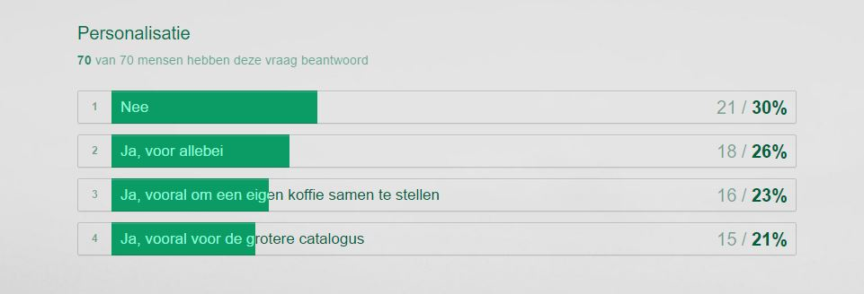
70% is interested in the application. 30% is not.
Out of that 70%, 26% is interested in as well as a bigger online catalogue as in the personalization option. 23% wants the app for the personalization while 21% is more interested in the bigger catalogue.

Interested in application – online payment
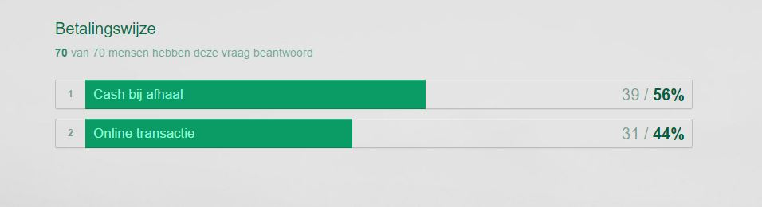
56% would still pay cash when they receive their order. 44% would like to pay online.

Belgium
We took a survey off of 256 people in Belgium and came up with these final results.

Who are the candidates who participated in the survey?

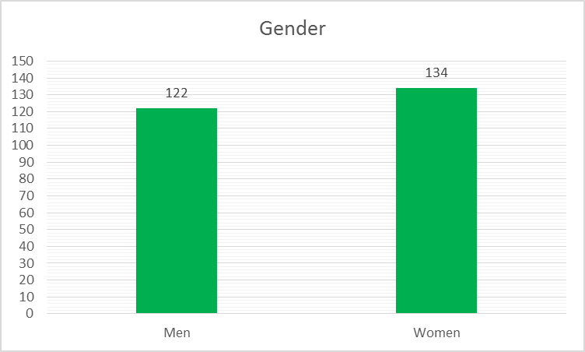
According to gender
Almost 48% of the candidates were considered ‘male’, the other 52% were female candidates. This could conclude that females are more likely to visit Starbucks than men, but the difference is rather small, so no real final conclusions can be made out of this.

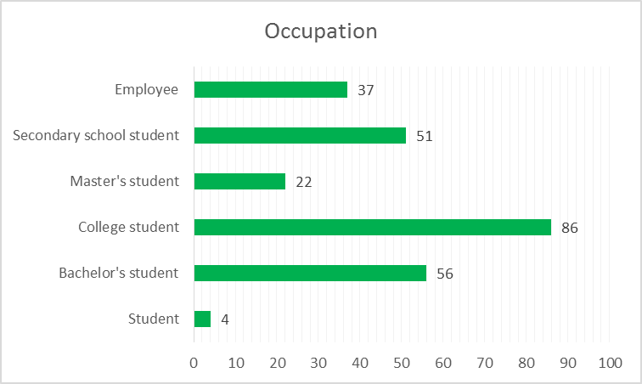
According to occupation
Most of the candidates were younger people who were still in school. Only 1,6% of the candidates stated they were just students. The other 84% of the students stated they were either Master’s, Bachelor’s or College students. The remaining 14,4% were employed people, who also seemed to show great interest in the app since it is beneficial for them during rush hour.

What were the results?

The estimated waiting time

According to the survey, most people believe to have to wait between 4-6 minutes for their order to be ready for consumption. In total, 58,6% of the candidates believes this is the average waiting time. 30,1% believes that the average waiting time is way shorter, reaching to only 1-3 minutes on average. The remaining 11,3% states to wait for an average of 7-9 minutes. Out of this, we can conclude that the waiting times are around 5 minutes on average.

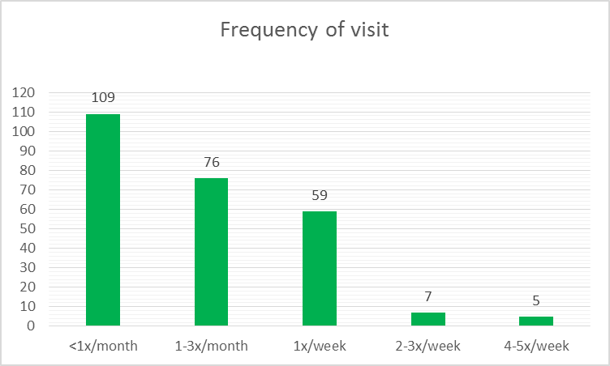
Frequency of visit
Most of the candidates only visit sometimes during the year. In total, 42,6% believes that they only visit Starbucks less than less than once every month. An average of 29,7% thinks they visit between 1-3 times every month. Visiting once every week is another 23%, with the remaining 2,7% visiting between 2-3 times/week and 2% visiting Starbucks on an average of 4-5 times/week. We can conclude out of this that a lot of people don’t visit Starbucks that frequently, meaning an application could either make it more convenient for them to come back, or bring in new customers who haven’t visited Starbucks at all.

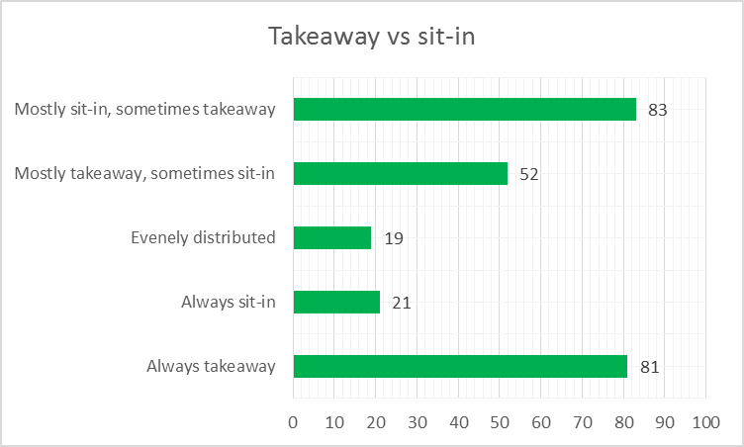
Takeaway vs. Sit-in
We conclude that most people prefer to either Always do takeaway, or mostly sit-in and sometimes do takeaway. A total of 31,6% prefers to always do takeaway and a total of 32,4% prefers mostly sit-in, but also sometimes takeaway. The remaining 36% has a different preference, from always sit-in to mostly takeaway but sometimes sit-in. With this we conclude that takeaway is a popular choice and Starbucks should take advantage of that with the application. This way busy people don’t have to queue up with the others who take their time with a preferred sit-in. With the app, time can be saved and people preferring takeaway can utterly benefit from this.

Time willing to wait
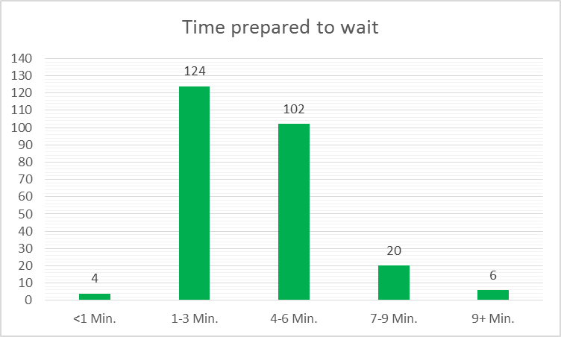
According to the statistics, more than 48% doesn’t want to wait longer than 1-3 minutes. This way be a problem as we’ve already concluded that the average waiting time would be around 4-6 minutes. Another 40% would be willing to wait no longer than 6 minutes. This is a more acceptable result. The other 10% is willing to take their time and wait for a minimum of 7 to even 9+ minutes. Then there’s a remaining 1,5% who are in a rush and want their order as soon as possible (willing to wait <1min). This concludes that the waiting times are too long for most people. Using a Starbucks application would be beneficial for the people who feel like they have to wait too long, as they can simply place their order in advance.

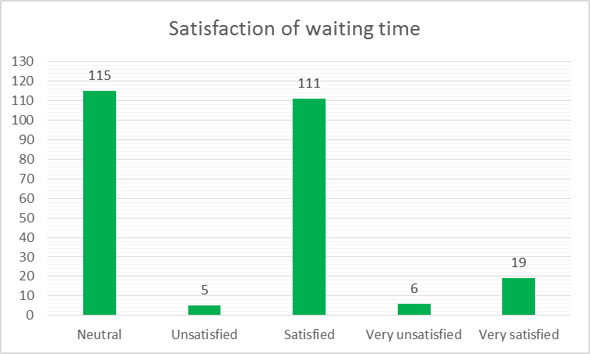
Satisfaction of the waiting times

According to the results, 45% of the customers feel neutral about the waiting times and don’t have any specific remarks about them. Only 4,3% feels slightly to very unsatisfied about the waiting times. These people are as concluded in quite a rush and don’t want to waste time waiting for their order. The remaining 50,7% feels slightly to very satisfied and doesn’t feel any need for improvement.

But would the customer be willing and able to use a Starbucks application?

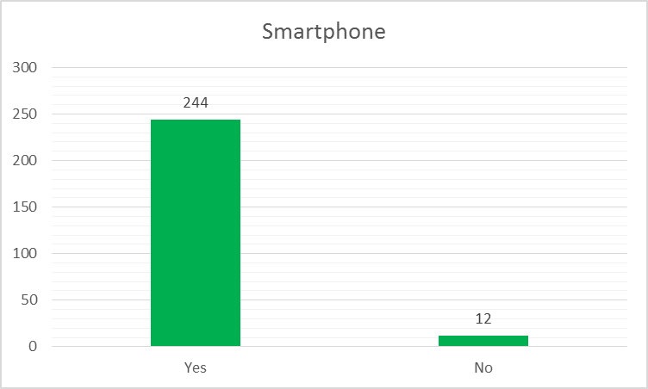
Do the customers own a smartphone to be able to use the app?

According to the survey, only 4,7% of the candidates does not own a smartphone. The other 95,3% does and would be able to use the application to order their favourite drinks/snacks through their phone.

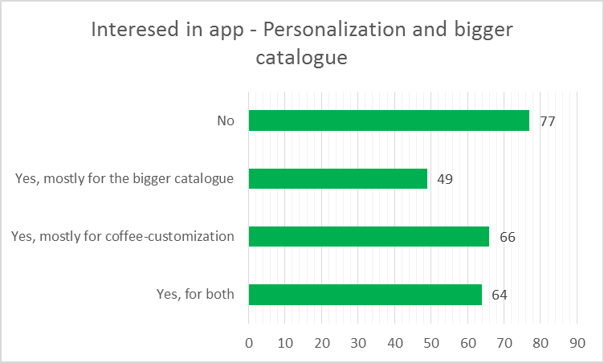
Is there any interest towards app-personalization and a bigger catalogue?

According to the results, more than 30% is not interested in any of these options that the application has to offer. The remaining 70% is though, with 25% being interested in both coffee-customization and a bigger catalogue. Another 19% is interested in mainly the bigger catalogue and the remaining 26% is mainly interested in the customization option. Concluding that a total average of 70% would be interested in the options that the application has to offer.

Is there an interest towards online payment?

It is obvious in this graph that most of the candidates preferred to use cash instead of online payment methods. With a total of 53% willing to pay with cash and the remaining 47% willing to try online payment methods. Luckily, the application offers both options so there would be nothing to worry about.

Conclusion
Is the Belgian market ready for a Starbucks app? The answer is yes.
Even if the Belgians prefer to pay cash instead of via online methods, the app could adjust itself to this. Both paying online or paying cash in the shop is an option the people who would pay online would like to receive a ‘bonus’ because of their customer loyalty. 70% of the interviewees would download the Starbucks. Why?
The research team came up with the following results:

FOR THE CUSTOMER
- Most of the customers feel neutral about the waiting time in the Starbucks shops. If they could use a fast lane for app users this number of people will go down and people will feel more satisfied with the quick service.
- The customer would have more time to think about what they could order BEFORE entering the shop while going through the catalogue on their smartphone. The feeling of satisfaction will be higher because they now have a wider variety of products they can choose from.
- The customer would have the chance to personalize their order and save it on their phone. By this they can try out new things and have a clear view on the prices of each personalization option.
- 95 percent of the interviewees has a smartphone. People check their phone about 80 times a day. The amount of interactions of customers with Starbucks will rise and this will have a direct influence on their customer behaviour. (CLARKE, 2015)

FOR STARBUCKS
- People don’t visit Starbucks that frequently. They have a lot of customers but the customer loyalty could improve by introducing the app. Not only will it make it more convenient for the customers to come back, their general Starbucks experience will change. People would have new reasons to visit Starbucks and the customers who already are doing this would benefit from the advantages of the app (waiting time, customization, catalogue, …) and it could give Starbucks the new breath they had been looking for.

Reflection
For the course of International Marketing&Research Jelle Van de Perre, Ruslan Podgaetskiy, Anthony Phan and I made a survey. We did field research in multiple cities. The survey I use for this assignment is the one we used for Brussels. The survey itself is in Dutch. The survey was made with Typeform. As you can see we've implemented the Starbucks colour pallet so that our survey would look more professional and in the Starbucks house style. It was really fun to hold our survey on the field. It is something else than just posting it online and asking friends to fill it in. You can interpret the questions more specifically because you can see and feel the emotions of the interviewee. When visualising the answers we immediately saw the results of our questions and we received the results we were hoping for. One of the disadvantages for holding field research is that we ‘only’ have 70 results for this survey (in Brussels). It takes a lot of time for doing this but I enjoyed it. I am definitely using Typeform again in the future because it is such an easy way to create a visually attracting survey, and it is also easy to analyse your results since you can also link it to Google Analytics.

