Report: Content Management Systems Assignment
In this report I’ll be comparing 2 content management systems. A content management system, or CMS, is a software application that is used to create and manage digital content. Drupal and Joomla will be compared. My personal experiences and facts and figures found online will be used as my discussion criteria.
Table of content
Drupal VS Joomla 1
What is Drupal? 1
What is Joomla? 1
Advantages 2
Own Thoughts 2
Instructional video Drupal 2
Conclusion 2
Reflection 2
Sources 3

Drupal VS Joomla
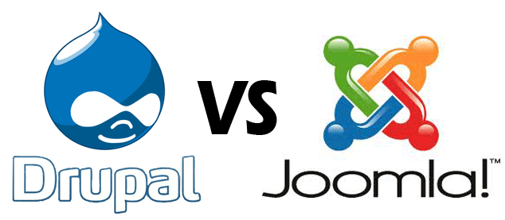

What is Drupal?
Drupal is an open source content management platform powering millions of websites and applications. It’s build, used, and supported by an active and diverse community op people around the world.

What is Joomla?
Joomla is an award-wining CMS, which enables you to build websites and powerful applications. Many aspects, including its ease-of use and extensibility, have made Joomla the most populat website software available.

Advantages
Drupal
Technically Advanced: Drupal is more technically advanced than Joomla. It's nice for thecnical people who want to put some more effort in their work.
Improved Performance: Drupal pages normally load more quicky so have a faster response time than those of Joomla.
Customizable: Drupal has a lot of themes, plug-ins and other configurable options which makes it very easy to customize your stie to your own likes. Developers can directly edit the root files it they want to make more significant changes.
Price: Free

Joomla
Social Networking: With Joomla you can easily run your social network which can be a powerful asset for a site.
Commerce Sites: Setting up an online store is very easy. It doesn't require that much effort as it would be with Drupal.
Not too technical: You can simply run a Joomla site without any technical support. You can say it's more user friendly to use than Drupal.
Price: Free

Own Thoughts
Drupal is the most powerful content management system. While using this program I noticed that I should have a basic knowledge of HTML to fully master the program. It would be more easier for me to work with the program and fix upcoming problems. I find Joomla very easy to use. It can do anything I want without having any programming knowledge. I think there are less possibilities of what you can do compared to Drupal but that you'll only use those on a more advanced level.

Instructional video Drupal
The following link provides you a free beginner course for Drupal. This is also the one I used to test Drupal for the first time: https://www.youtube.com/watch?v=-DYSucV1_9w

Conclusion
I think Joomla is the best option for me to use since it gives me the option to get started quickly with a business website and still has all the features I want to use. Maybe when I want to go further en customize more and make everything a little more interesting I'd consider using Drupal.

Reflection
Why did I choose to compare Drupal and Joomla? Well I had already worked with sites like Wix and Wordpress and I wanted to test some new programs for this assignment. Drupal and Joomla were the first ones I found online so I decided to test them.
As for the assignment, I think it was a good assignment, not only for those who have never been in contact with a CMS before but also for those, like me, who had to try out a new program.

Sources
Mening, R. (2015, December 28). wordpress vs joomla vs drupal. Retrieved December 12, 2016, from https://websitesetup.org/cms-comparison-wordpress-vs-joomla-drupal/
OSTraining. (2015, November 19). Drupal 8 Beginner, Lesson 1: Introduction to the Course. Retrieved December 12, 2016, from https://www.youtube.com/watch?v=-DYSucV1_9w
Rouse, M. (2014, June 3). content management system (CMS). Retrieved December 10, 2016, from http://searchsoa.techtarget.com/definition/content-management-system

