Assignment Social Media 1
- Top 3 Social media I am on
Facebook
The main reason why I use Facebook is to host and to join multiple groups with people in it. Groups of friends, groups for school assignments, groups for my sport club, etc. It is the most easiest way to stay in contact with those people and talk about the specific group topic.
The second reason is to follow people and companies their Facebook page to stay up to date. By simply liking or following the page/person you are able to see all their latest posts, pictures and video’s in your Facebook feed.
Instagram
For me pictures posted on Instagram have to be more exclusive than those on Facebook. That’s why I don’t follow all my Facebook friends on Instagram. I only follow those who can post something more interesting that matches with their Instagram account. Your account has to have a specific theme, for example lifestyle, clothing, travelling, … That’s why I only post my best travel pictures on Instagram. By this I’m making an exclusive high quality travel picture album. It’s also fun to browse the Instagram feed to see the exclusive posts of the account’s you are following.
LinkedIn
I try to reflect my professional life on LinkedIn and connect with business people I’ve met. I see this all as a preparation for the moment that I’ll join the working market so people and companies can find me online and see what I’m capable of and what I’ve already done in the past. I also follow the companies that I’m interested to follow.
- Different companies that are using my social media?
Facebook
I think almost every company in the world has a Facebook page. Fortune 500 companies, big scaled companies, small scaled companies and start-ups. I also think that now, in 2016, the moment you found a company, a business or an organisation, that a Facebook page is instantly made.
Example: Squash club Futuresports
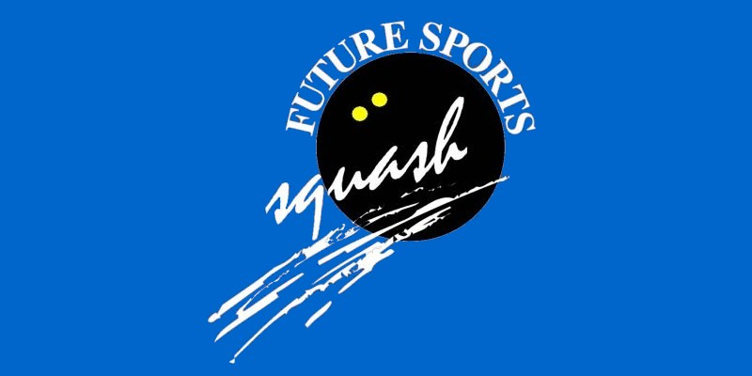
The squash club in Zottegem has recently founded a Facebook page. Their main reason is to attract new players for their club. By often posting pictures of their players playing in training sessions, tournaments or of players enjoying a beer together they want to show that their club is perfect for everyone who’s searching for a new hobby in Zottegem.
Instagram
Which companies use Instagram? I think mostly international companies that sell goods like clothing, tech and other things to promote their products. Also large scale companies such as Coca-Cola will have an Instagram account to show and promote their new ideas and social media campaigns. Also local companies are beginning to promote themselves on Instagram.
Example: Grand Frank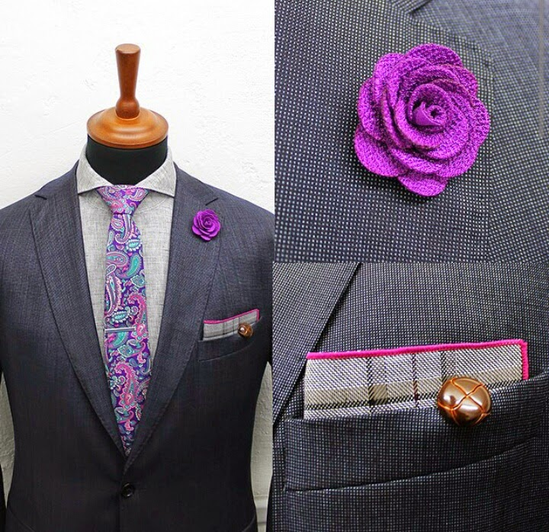
Grand Frank is a fashion brand that started their business on Instagram. By getting a lot of followers they eventually could start their business on a bigger scale and are now delivering their products internationally.
LinkedIn
More and more businesses are starting to use LinkedIn. In the beginning only large scale companies were using it to find employees and to promote their business by regularly posting updates about their company’s research, strategy and all other matter related to business. But nowadays the small scale companies and start-ups are also finding their way to LinkedIn.
Example: Google
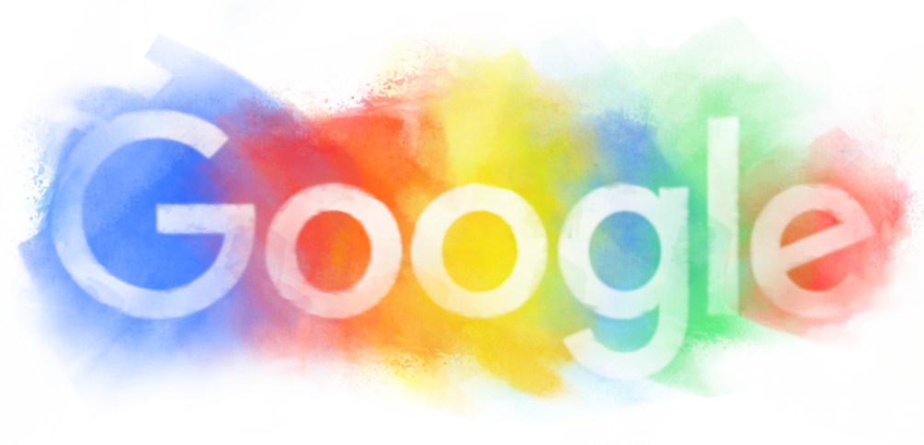
I’m following Google on LinkedIn because I want to stay up to date about their latest ideas, technologies, changes in their business and so much more.
What are companies trying to achieve with social media and what is the usefulness?
It’s all about promoting and brand awareness.
Facebook
It’s important that you start building your fanbase on Facebook. Try to post your link anywhere you can and include a social icon onto your website. Once you’ve created a following it’s important to update your status by sharing photos, posts and videos of your products, offers and services. It is also important that you interact with your audience. The more people are engaging, the more frequently other people will stumble upon your page.
Facebook Advertising is really important for businesses who are active on Facebook. It uses graphs and activities to pinpoint your buyer’s demographics. The ads are likely to bring in new customers that are actually looking for your product.
Instagram
Instagram is one of the most effective brand-building tools available, for retailers, restaurants, travel agencies and now also increasingly important for every kind of business. Compared to Facebook, an Instagram follower delivers 58 times more engagement.
New people are reached in the way they wanted to: with visuals and short messages. You can not only pay so your posts are more likely to be shown to new people but you can also interact with your followers on a more personal level. By rewarding them with promo codes or to create engagement with contests businesses on Instagram are now booming and Instagram is becoming more and more important.
LinkedIn
LinkedIn is different from social media like Facebook or Instagram. It is specifically designed for business and professionals. It’s mainly used for people and businesses to showcase their experience and professional thoughts.
LinkedIn has a lot of business features such as Pulse, Company Pages and InMail but the most important one are the Groups. Not much conversation is happening LinkedIn pages so people from the same company or industry meet and talk in these groups. They ask and answer questions, engage in conversations and show each other their interests. It’s the perfect way to showcase your industry expertise.
- Facebook specific
When I look at the ad that are being showed to me the moment I am writing this sentence I notice 2 things. The first add is from Zalando. It’s an add promoting Nike shoes. I’m not looking to buy shoes, neither am I interested in Nike and I haven’t been web browsing for shoes or Zalando. I think this is an ad where Zalando pays to reach as much people as possible by popping up with a lot of random people, trying to expand their customer base.
The second add is one of a virtual reality museum. Lately I’ve been looking up a lot of information about virtual reality so the link has been made. Facebook shows me an ad ‘I want to see’.
- Conclusion and reflection
I analyses Facebook, Instagram and LinkedIn and I tried to find 3 totally different companies to see how each of them worked in a different way. I felt somewhat insecure during the task because at first I didn’t really know how I had to do it but after all I am satisfied with the results. If I had to to it again I think I would go more in detail and look up more information of how each company really tries to promote itself on social media.
- Sources
Egan, K. (2016, May 19). the difference between facebook twitter linkedin google youtube pinterest. Retrieved December 12, 2016, from https://www.impactbnd.com/blog/the-difference-between-facebook-twitter-linkedin-google-youtube-pinterest
LePage, E. (2015, June 17). how to use instagram for business. Retrieved December 12, 2016, from https://blog.hootsuite.com/how-to-use-instagram-for-business/
Sprung, R. (2013, January 23). 5 ways marketers can use instagram. Retrieved December 12, 2016, from http://www.socialmediaexaminer.com/5-ways-marketers-can-use-instagram/

