Work observation report

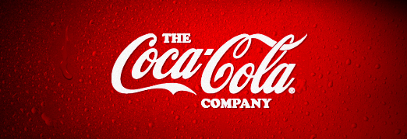
Company presentation

Coca-Cola Company
The Coca-Cola Company is the world's largest beverage company, refreshing consumer with more than 500 sparkling and still brands. Together with their bottling partners, they are ranked among the world's top 10 private employers with more than 700,000 system associates.
The Company's portfolio features 20 billion-dollar brands, including Diet Coke, Fanta, Sprite, Coca-Cola Zero, vitamin water, Powerade, Minute Maid, Simply, Georgia, Dasani, FUZE TEA and Del Valle. Globally, they are the No. 1 provider of sparkling beverages, ready-to-drink coffees, juices and juice drinks. Through the world's largest beverage distribution system, consumers in more than 200 countries enjoy their beverages at a rate of more than 1.9 billion servings a day.
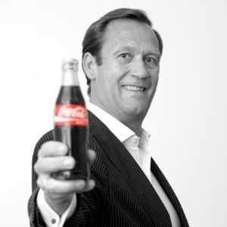
With an enduring commitment to building sustainable communities, the Company is focused on initiatives that reduce our environmental footprint; support active, healthy living; create a safe, inclusive work environment for their associates; and enhance the economic development of the communities where they operate.

Manager presentation

Alain Puttemans
Function: International Account Director
Previous employers: Coca-Cola Enterprises Belux, Henkel
Education: Katholieke Hogeschool Mechelen

As an international account director of the Coca-Cola company Mr. Puttemans is responsible for the company’s overall customer strategies, business results and relationships with the international buying groups on a global scale. His primary responsibility is to cut a deal with the global headquarters of the customer and then work in collaboration with the bottlers in each key country to plan and execute these strategies at a local level.

Organogram
The Coca-Cola Company has a corporate segment that is responsible for giving the Company an overall direction and providing support to the regional structure.
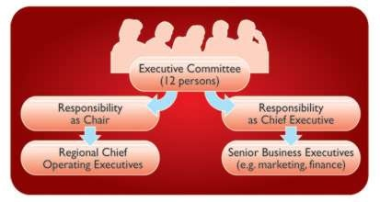
Key strategic decisions at The Coca-Cola Company are made by an Executive Committee of 12 Company Officers. This Committee helped to shape the six strategic priorities set out earlier. The Chair of the Executive Committee acts as a figurehead for the Company and chairs the board meetings. He is also the Chief Executive Officer (CEO) and as such he is the senior decision maker. Other executives are responsible either for the major regions (e.g. Africa) or have an important business specialism e.g. the Chief Financial Officer.

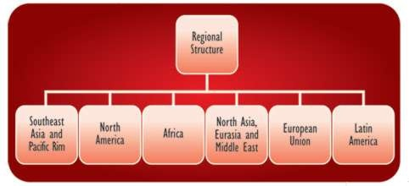
As a company whose success rests on its ability to connect with local consumers, it makes sense for The Coca-Cola Company to be organized into a regional structure which combines centralization and localization. The Company operates six geographic operating segments - also called Strategic Business Units (SBUs) - as well as the corporate (Head Office) segment.

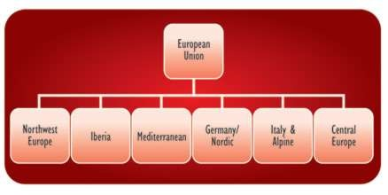
Each of these regional SBUs is sub-divided into divisions. Take the European union, SBU, for example. Belgium fits into the Northwest Europe division. This geographical structure recognises that:
- markets are geographically separated
- tastes and lifestyles vary from area to area. As do incomes and consumption patterns
- markets are at different stages of development.

Mr. Puttemans in in charge of the European Union. It’s his job to cooperate with the international- and national account directors that are in charge of these divisions (Northwest Europe, Iberia, Italy & Alpine,…).

Log of activities
Date/Time | Activity Description | How I Feel | Duration | Value (High,Medium,Low,None)
13/11/15 - 9AM | First encounter | Excited | 15 minutes | High
13/11/15 - 9.15AM | Tour of the building | Curious | 30 minutes | High
13/11/15 - 9.45AM | Introducing the assignment | Nervous | 15 minutes | Low
13/11/15 - 10AM | Mail – reading, answering, getting more information | Eager to learn | 45 minutes | High
13/11/15 - 11.45AM | Making some phonecalls | Neutral | 15 minutes | Low
13/11/15 - 12PM | Lunch | Happy | 60 minutes | High
13/11/15 - 1PM | Interview | Amazed | 20 minutes | High
13/11/15 - 1.20PM | Teleconference | Eager to learn | 105 minutes | High
13/11/15 - 3.05PM | Transport to Mr. Puttemans’ house | To be honoured | 30 minutes | None
13/11/15 - 3.35PM | Business call | Eager to learn | 70 minutes | High
13/11/15 - 4.45PM | Spare time with Mr. Puttemans | Fortunate | +-5 hours | High
15/03/16 - 9AM | Mail | Eager to learn | 30 minutes | Medium
15/03/16 - 9.30AM | Planning business trip | Eager to learn | 45 minutes | High
15/05/16 - 10.15AM | Business call | Eager to learn | 120 minutes | Medium
15/05/16 – 12.15 | Networking | Eager to learn | 50 minutes | High

Interview with the manager
Can you give a short description what you, as an international account director, need to do at the Coca-Cola company?
I’m responsible for the company’s overall customer strategies, business results and relationships with international buying groups on a global scale. My primary responsibility is to cut a deal with the global headquarters of the customer and then to work in collaboration with the bottlers in each key country to plan and execute these strategies at a local level.

Which problems do you occur in your job?

Challenges from a professional perspective:
- Get internal alignment and validation from all involved parties (The Coca-Cola Company and all involved bottlers like CCE (Coca-Cola Enterprises), CCH (Coca-Cola Hellenic) and CCEAG (Coca-Cola Erfrischungsgetränke).
- Manage high demands and expectations of international organized customers.
- Manage and prioritize my agenda in a well-balanced way.

Challenges from a private perspective:
- Guarantee optimal work-life balance duo to international travel.

What constitutes your workday? I’m sure that there is a boundless supply of work to keep you work 24/7. So how do you decide when to go home?
A workday and the number of working hours are determined and driven by the agenda consisting out of travel, preparation of meetings and presentations.

What are the most important decisions you make as an account director?
Concluding international agreements.

Work-life balance is an issue of retention as well as productivity. Can you talk about your own view of how to navigate the tensions between getting work done and encouraging healthy lives outside the office linking them to time management?
A good work-life balance is driven by a well-managed agenda and its prioritization.

What are your norms around working on the weekends and in the evenings, answering email and voice email messages after hours?
Personally I don’t have any problem in case of urgencies on specific business issues to work (answering e-mails, voice mail messages, …) during the weekend or after working hours. We just have to make that it doesn’t happen on a structural and continuous basis. In order to guarantee a well work/life balance respect of weekends is crucial.

How do you encourage creative thinking within your organization? / How does the Coca-Cola company tries to be
Today’s market is always changing. Customers get bored and want to try new things. Our company needs to stay creative in its marketing strategy. That’s why Coca-Cola keeps introducing new products with innovating campaigns, for example the drinkable billboard campaign for Coca-Cola Zero in the US, or the Happy Caps campaign for students.

Do you have any tips for students who are willing to become a manager?
Inquisitiveness, accountability and entrepreneurship are critical factors for successful development in personal and professional life.

What is one characteristic that you believe every future manager should possess?
The most critical factors for successful development in personal and professional life are inquisitiveness, accountability and entrepreneurship.

Can you tell me your stance and the company’s stance, if it has one, on social media, using LinkedIn, Facebook, Twitter?
I don’t have Facebook or Twitter. But other managers do. The Company makes certain commitments concerning how we interact with the public and each other, and these commitments apply to interactions that occur on social media platforms as well. We expect the same commitments from all Company representatives, including Company associates and associates of our agencies, vendors and suppliers:
- Coca-Cola will be transparent in every social media engagement.
- Coca-Cola will protect our consumers’ privacy in compliance with applicable Privacy Policies, IT Security Policies, and laws, rules, and regulations.
- Coca-Cola will respect copyrights, trademarks, rights of publicity, and other third-party rights.
- Coca-Cola will be responsible in our use of technology and will not knowingly align our Company with any organizations or Web sites that use excessive tracking software, adware, malware or spyware.
- Coca-Cola will reasonably monitor our behavior in the social media space, establish appropriate protocols for establishing our social media presence, and keep appropriate records of our participation as dictated by law and/or industry best practices.

What’s your career story? How did you start and how did you end up becoming an international account director of Coca-Cola?
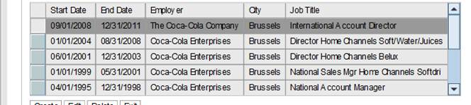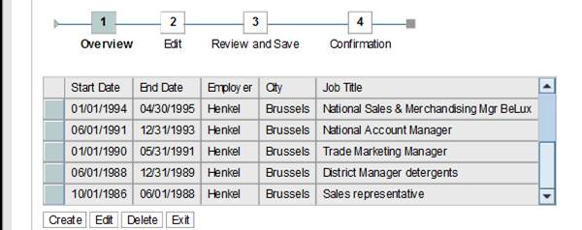

Reflection
When I first heard we had to do a one day internship I was thrilled already. Immediately I started thinking about where I could and should go. The goal I’d set for myself was to contact a well-respected manager within an international company. The first manager I contacted was also the last one since he instantly contacted me that I could follow him for a day. All communication was done by phone since Mr. Puttemans preferred oral communication to talk about the one day internship.
We arranged that I could come over to his office in Brussels at the 13th of November. When I arrived for the first time I was impressed by the building. A very huge building with a lovely entry. The entrance hall was decorated in the theme of Coca-Cola which is very attractive for the customers but it’s also a nice working environment for the employees. After a tour in the building I was fascinated by the interior design and the fact that there are multiple companies working in the building.
Then the work day started. Mr. Puttemans explained to me that he could choose his own working hours as long as he gets to his monthly quotas. This has shown me that time management is a very important aspect in the daily life of a manager. I’ve put the activities we’d done during the day in the log of activities. I’ve also added the value of that particular activity. How I’ve experienced it and felt about it. I never thought that he would receive so many mails during the day. I learned that he only answered on the important ones immediately and postponed the others for a moment later on the day. The most interesting parts of the day were the business call and the teleconference. I had the chance to take a look into his preparations and I received his method to work out a call plan and a meeting report. This led to conversations that were fully in hand of Mr. Puttemans where superfluous discussions were averted and that he had everything in control. Afterward we went for a drink and he invited me for another day at the office. I accepted his invitation because I was truly inspired by his work and by his working method and I simply couldn’t refuse an extra chance to learn.
I’ve discovered new methods how to prepare for difficult tasks. I’ll definitely implement the way Mr. Puttemans solve problems into my own study career. I think this observation was a great introduction to the business world but I think it would be more interesting if the period could be a week instead of 1 day. In this way, students can observe and help the manager in more diverse tasks than they can in one day.

